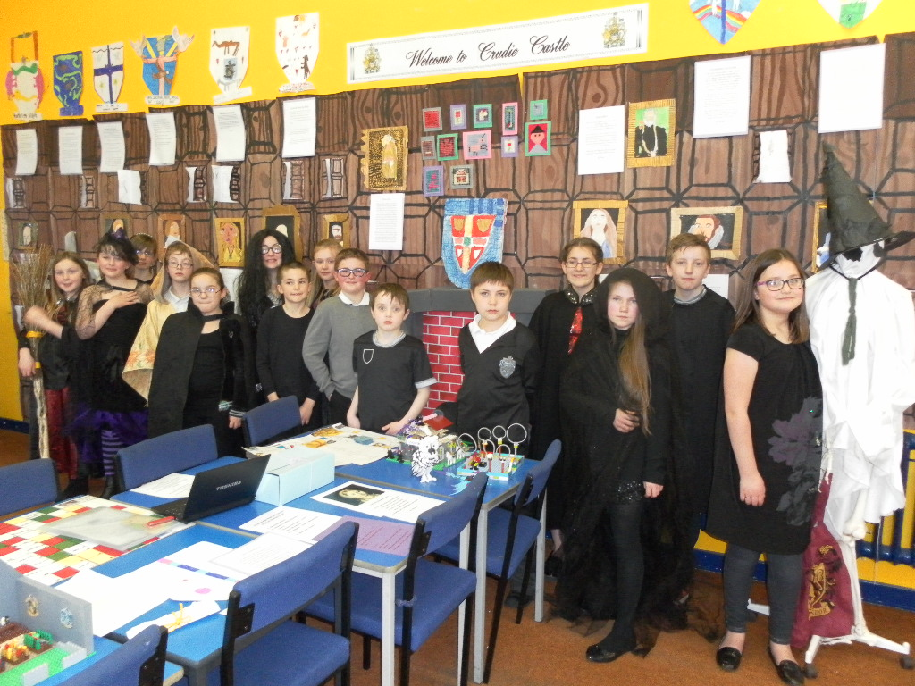
Crudie School
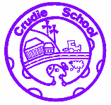
Curriculum Rationale and Design
Crudie School
Curriculum Rationale and Design
It is our vision that at Crudie School we will inspire every child to reach their full potential academically, emotionally and physically. Working together to create confident and responsible citizens ready to embrace future challenges.
At Crudie School we value determination, responsibility, respect, caring and cooperation.
Together with parents, pupils and staff we developed the following set of aims:
- We aim to be a healthy, happy and sustainable school.
- Through experiences and outcomes of Curriculum for Excellence, we will provide opportunities that will enable our learners to become responsible citizens, confident individuals, effective contributors and successful learners.
- We will help pupils to learn in an exciting way, using resources inside and outside, and that nurture life skills.
- We will teach in an environment that increases interest levels and challenges our learners.
- We will support every learner with all aspects of school life.
- We will keep parents informed and involved.
- We will ensure that all pupils feel safe and respected.

Through our curriculum our pupils
- contribute to our school ethos and school community
- Are given a broad general education through delivery of the Curriculum for Excellence experiences and outcomes
- Celebrate and share their personal achievements
- Develop skills required for learning, life and work
- Are supported during their progression through the experiences and outcomes
We aim to achieve this through the seven principles for curriculum design.
Challenge and enjoyment: In Crudie School we challenge individual learners in the experiences we provide. Our learning activities are planned so that our pupils have fun and are engaged in their learning. We have a fantastic outdoor space and we try to utilise this where we can to enrich the learning opportunities we provide.
Breadth: Crudie School is composed of two composite classes and as such we have planned carefully to ensure that we are providing a breadth of experiences across the curriculum.
Progression: We monitor and track our pupil progress at key points throughout the year so that we know individuals are making progress at a pace appropriate to them.
Depth: At Crudie School we plan experiences so that pupils will learn in depth the skills they require to apply their learning across the curriculum.
Personalisation and choice: Our planned experiences give opportunities for our learners to express their learning in their own individual way, taking account of differing learning styles. In topic work in particular, learners are involved in deciding what they want to learn about and how they will go about achieving this.
Coherence: We aim to provide a coherent learning experience, making links across the curriculum and between this learning and skills for life and work.
Relevance: We encourage our learners to see how their learning has an impact on their present and future lives.

“The curriculum is the totality of experiences which are planned for children and young people through their education, wherever they are being educated. It includes the ethos and life of the school as a community; curriculum areas and subjects; interdisciplinary learning; and opportunities for personal achievement.”
Building the curriculum 3: A framework for Learning and Teaching

The Ethos and life of the school as a community
At Crudie School we have a positive ethos with a climate of respect and trust where children are supported and listened to. Our pupils have a sense of pride in our school and are happy to learn here at Crudie. At each stage of our pupils’ education they have a chance to contribute to the ethos and life of the school. All pupils are part of the Pupil Parliament and have an equal opportunity to make decisions in the school. We have school groups which all pupils from P3 to P7 are involved in. These groups are the Nature Nurturers, Health Heroes, Safety Soldiers and Waste Warriors. Through these activities we are enhancing our learner’s confidence and creating responsible citizens who know that their opinions are valued and respected.

Curriculum areas and subjects
The Curriculum for Excellence provides Crudie School with a set of experiences and outcomes from which staff can plan activities that meet the needs of all learners and support them in making connections in their learning.
The curricular areas are organised under the following subject headings:
- Literacy and English
- Numeracy and Mathematics
- Health and Wellbeing
- Science
- Social Studies
- Expressive Arts
- Modern Languages
- Technologies
- Religious and Moral education
Literacy and Numeracy experiences and outcomes develop critical, logical and creative thinking skills which can then be applied to and permeate the whole of our curriculum.
Many of the Health and Wellbeing experiences and outcomes span two or more levels as they are applicable throughout life.
Interdisciplinary Learning (IDL)
Interdisciplinary Learning is about providing pupils with opportunities to make connections across various areas of the curriculum and apply their learning in new and different ways.
At Crudie School, we carefully plan contexts in which this can take place.
For example:
- During a rainforest topic, pupils made a link with a school in a rainforest in Australia. We wanted to make comparisons between their school and our own. The pupils thought about what the other school would like to know and created a script which they then acted out and filmed before using technology skills to edit their work and send off to them.
- When undertaking a novel study on Harry Potter and the Philosopher’s Stone, pupils were asked what the science was behind the magic at Hogwarts. Pupils then had to identify experiments that they could demonstrate as a magic trick and present, to an audience, the science that was involved in making the trick look like real magic.

Personal Achievement
We celebrate our pupil’s achievements on a weekly basis, whether these take place within the school setting or out-with. Every week the whole school meets and during this time Geoffrey’s Star of the Week is chosen and we present awards to those who have been keeping our values during the week. These achievements are celebrated on Geoffrey’s success wall and recorded in the achievement book.
Our pupils regularly set their own learning targets and talk about their own and their peers work. Every two weeks each class chooses their best piece of work to share on our Learning Wall. Pupils are able to evaluate their work and decide which pieces they want to highlight within their Profile on One Note.
Meeting learner’s needs
At Crudie School we understand that each of our pupils are individuals and as such will learn at their own pace and using their own learning style.
We support our pupils to do the best that they can and where there are barriers to their progress we believe in putting in the “right support, in the right place, at the right time” in line with Aberdeenshire Council’s model.
There are a range of ways in which we can support a child:
- Through following the principles of GIRFEC.
- Effectively allocating Support for Learning time where it will make the most impact.
- Differentiating work to meet the needs of individuals.
- Identifying environmental factors that could have an impact on learners with specific needs.
- Working in tandem with parents.
- Working closely with our partner agencies.
- Setting IEPs (Individualised Education Plans) to target specific areas.
Through this we believe we can get it right for every child.
Transitions
Change can be difficult for children and their parents so at Crudie School we aim to make transitions go as smoothly as possible; especially between preschool and P1, and P7 and S1.
Preschool to P1: The majority of our pupils come in to P1 from Crudie Playgroup. During their time at Playgroup, children have a range of opportunities to become familiar with the school. The Playgroup come in to the school every week for gym sessions and are invited along to assemblies, concerts and Community Cafes. In the term preceding entry to P1, Playgroup pupils take part in a shared playtime once a week, the teachers visit Playgroup on a series of occasions to work with learners and there is a three day visit to the school. Parents are provided with induction meetings to learn about the school, what to expect and how they can support their child in P1. Learning packs are sent home for parents and children to share. P7s are buddied up with the new P1s and are there to help them get used to the school routine. P1s have a two week phased entry at the start of the session to help them settle in to their new surroundings.
P7 to S1: The majority of our pupils leave Crudie School to go to Turriff Academy although we do have some who attend Banff Academy. Guidance Teachers from the secondary come to speak to our P7s and answer any questions they may have. P7s from the cluster schools all have the opportunity to attend a five-day residential trip to Loch Insh. During this time, in addition to developing key skills in problem solving and cooperation, they meet pupils from the other schools who will be going to secondary with them. Pupils who don’t attend Loch Insh are given a similar experience based in the Turriff area.
Pupils who require extra support with transition are referred to Bridging Group which gives additional opportunity to visit the Academy. Learners get a four day visit in June to their secondary school.
Crudie School is part of the Teacher Learning Community that exists between feeder primaries and Turriff Academy. This supports the development of excellent practice in our learning and teaching.
At all stages communication between staff is key and information is passed on so that prior learning is built upon and support needs continue.
Crudie School in the community
Crudie School is in a rural setting in the small hamlet of Crudie and we have vital links with our local community. Every second term we host a Community Café which parents and community members are invited to and it is an opportunity for everyone to see the work the children have been doing and share in the learning. Our local community has a great many strengths and they have been able to support our learning and teaching in a range of ways. For example; We have parents come in to help pupils in the library and to run one of our school groups. The Turriff Young Farmers worked with our youngsters to engage them in learning about farming in the future. The King Edward and Gamrie Community Council hold their meetings in the school and invited the pupils to design their new logo. There is also a Community Garden Committee on which we have members of the school and playgroup, including pupils. This committee supports the work of the school and playgroup with our outdoor areas.
In the wider context of the community, our pupils have regular opportunities to support local and larger charities. The children make a democratic decision, through Pupil Parliament, as to who to raise money for when planning their fundraisers.

